**Exploring NYC Neighborhoods for a Dog Friendly Restaurant**

**Introduction**

As a dog lover and food enthusiast, I have always been excited about dog friendly bars and restaurants. I set out to find which neighborhood in NYC would be best to open a dog friendly restaurant. NYC real estate can be expensive, and restaurants are competitive so it’s important for entrepreneurs to find the right location. Business owner and entrepreneurs who have a similar interest in opening dog friendly businesses may find this report of interest. Additionally, someone moving or around NYC and has a dog may look to find the right neighborhood as well.

**Data**

I used Foursquare location data to retrieve a list of dog parks in NYC by searching “dog park” as a venue within a certain mileage. I cleaned up the results by converting the venues into a dataframe. From here, I mainly looked at location (latitude/longitude) as well as the Foursquare rankings of some of the parks on the list.

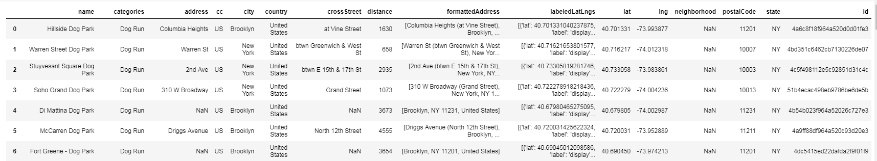

Aside from Foursquare data, I used Rent Café to find the average rent in each neighborhood in Manhattan, found [here](https://www.rentcafe.com/average-rent-market-trends/us/ny/manhattan/). I was able to import the data table from the website into a dataframe. I cleaned this up but converting the currency amounts to numbers. I also found the coordinates for each neighborhood and added new columns for the coordinates, latitude and longitude so I would be able to use this for a map. I did have to remove one row as the coordinates returned a NaN value.

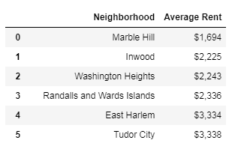

**Methodology**

After downloading the Foursquare data for dog park venues in NYC and converting the results into a dataframe, I set out to visualize the results in a map. First, I created a folium map centered in NYC with markers for each result. I was able to display NYC on the map by using the geolocator Nomnatim function to retrieve the geographical coordinates.

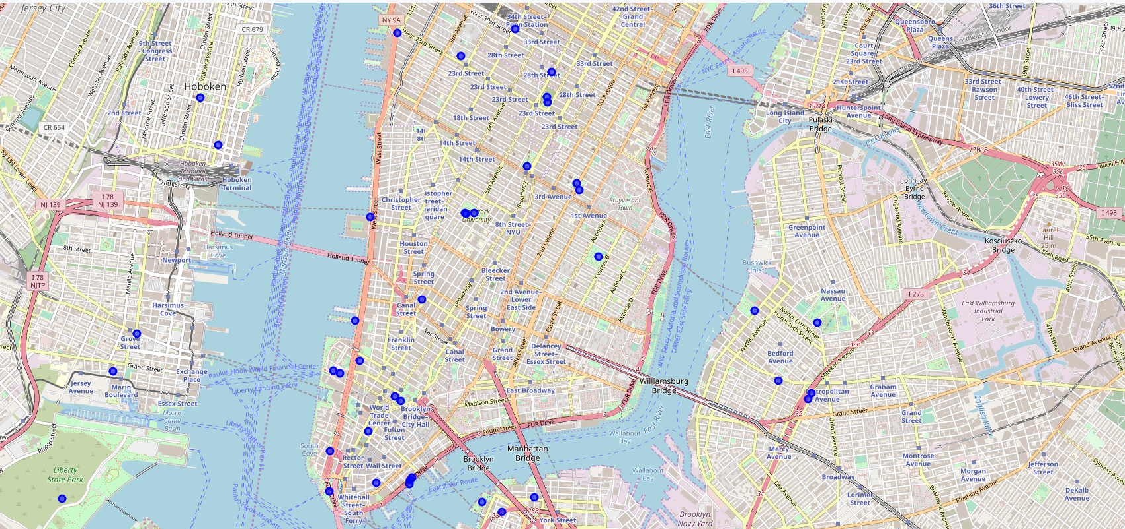

After taking a look at the map, I could see there were certain areas that had more than one dog park nearby. From here, I clustered the dog park locations on the map so the viewer can see which neighborhoods have multiple parks. This can show a general visual of where the most parks are located in the city.

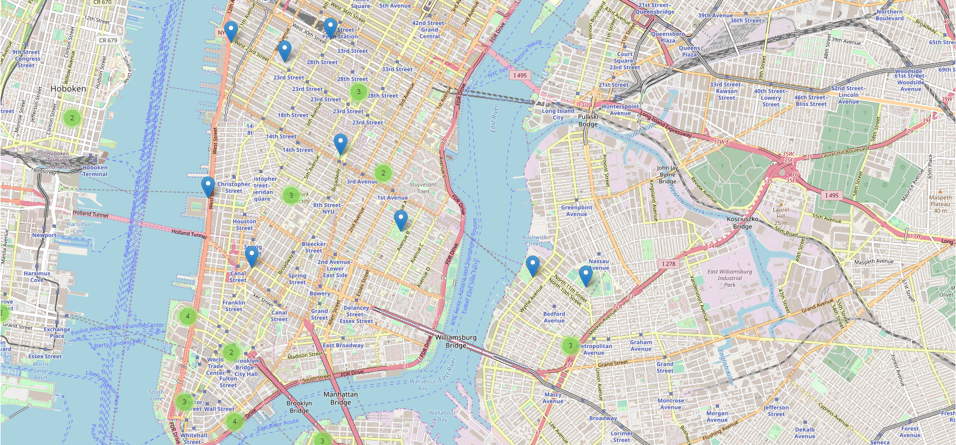

From here, I took a look at the ratings for some of the dog parks that were in the Foursquare results. The thought here was that just because there is a park or multiple parks in a neighborhood does not necessarily mean they get foot traffic and I wanted to get a sense of which ones were most visited or liked by Foursquare users. Specifically, I only looked at ones that were located in Manhattan (city column = New York)

After looking into the Foursquare data, I looked into another variable that is often considered when opening a new business: price. After downloading the average rent in each neighborhood in NYC, I used the geocode Nominatim function to retrieve coordinates for each neighborhood. I converted this into new columns showing the latitude and longitude so I visualize this.

I created a new map to display the rents visually. I used a calculation for the radius to show larger circle markers for higher rents and vice versa. I also split the data set into neighborhoods with an average rent above $4500 and those below. I displayed this using the circle marker colors so the viewer can easily visualize where the higher rents in NYC are vs the lower rents.

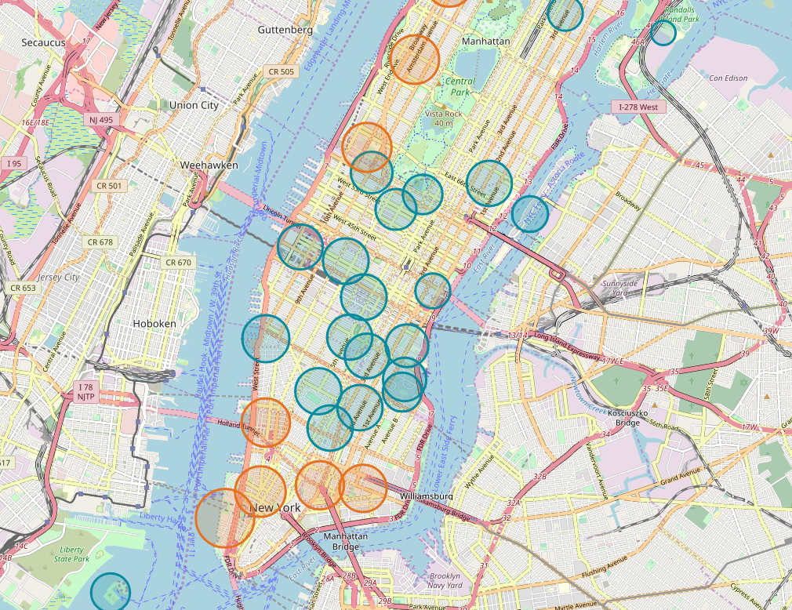

**Results**

The Foursquare search retrieved 50 dog parks in the specified radius surrounding NYC. The greatest number of dog parks are located downtown, close to the water. After this, there are several near NYU, Stuyvesant Town, and Flatiron.

Union Square Park was rated the highest at a 9.7. While almost every park that had a rating over 8, the following parks had a rating of 9 or above: Tompkins, Washington Square Park, City Hall Park, Bryant Park Madison Square Park, Pier 25. Several parks did not return ratings and East River Esplanade had the lowest rating at 6.4.

After looking into rent prices, the map showed a general trend of higher average prices downtown and on the upper west side, as shown by the orange circle markers. While the Foursquare results showed the highest number of dog parks downtown, a money conscious entrepreneur on a budget may look to open their business above Houston and below Central Park.

**Discussion**

If someone looking purely at the count of dog parks in an area, downtown would be the place to open a dog friendly business.

If someone were looking to open their business near the highest rated dog parks, they may look around one of the parks listed above in the results section with ratings over 9.

While the Foursquare results showed the highest number of dog parks downtown, a money conscious entrepreneur on a budget may look to open their business above Houston and below Central Park.

**Conclusion**

The Foursquare data was able to show valuable location information on where dog parks are located in NYC. There were some limitations and complications as some results were not actually dog parks. For example, a metro station, movie theater and Mexican restaurant were included in the results. The ratings were helpful to see which parks are most popular, though further analysis might include how many ratings were included for each to see if there is a consensus among several Foursquare users or just one. This might also help show which have more foot traffic based on how many user ratings there are. Further research might include looking into data on actual foot traffic if possible. In general, most dog parks that had ratings were rated relatively high. Improving upon the analysis might also look into the locations of registered dogs as more heavily populated areas in NYC with dog owners may be good to open a dog friendly business, despite the proximity to a dog park. Similar to the limitations of the initial Foursquare analysis, the rent average rent price information was a good place to start in terms of general location in NYC for higher and lower rents. However, when making an actual decision for opening a business, real available spaces to rent and actual price figures would be necessary to stay within a budget.